RIVER VALLEY HIGH SCHOOL
General Certificate of Education Advanced Level
Preliminary Examination 2024
Higher 2
H

GEOGRAPHY 9173/02
Paper 2 12 September 2024
INSERT 3 hours

READ THESE INSTRUCTIONS FIRST

This Insert contains all the Resources referred to in the questions.

___________________________________________________________________
This document consists of 7 printed pages and 1 blank page.

[Turn over

Resource 1 for Question 1

Map of Bukit Merah View and the sites of data collection

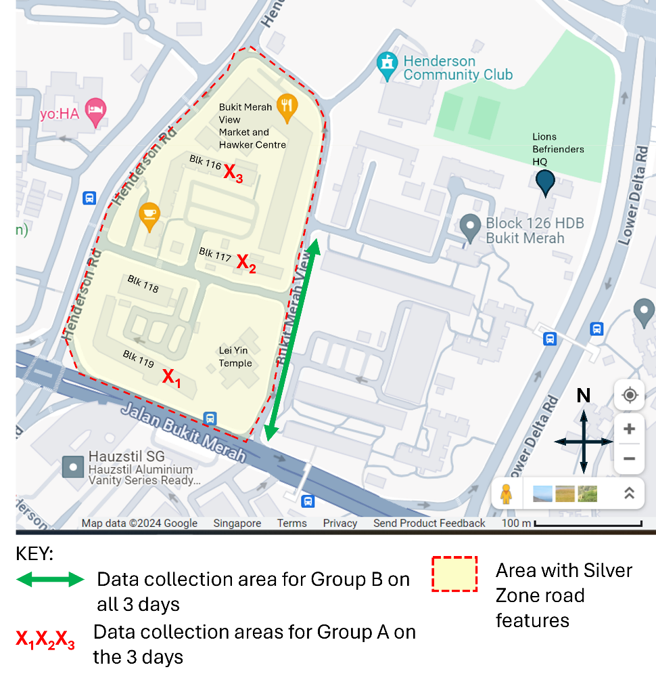

Resource 2 for Question 1

Silver Zone Features at Bukit Merah View

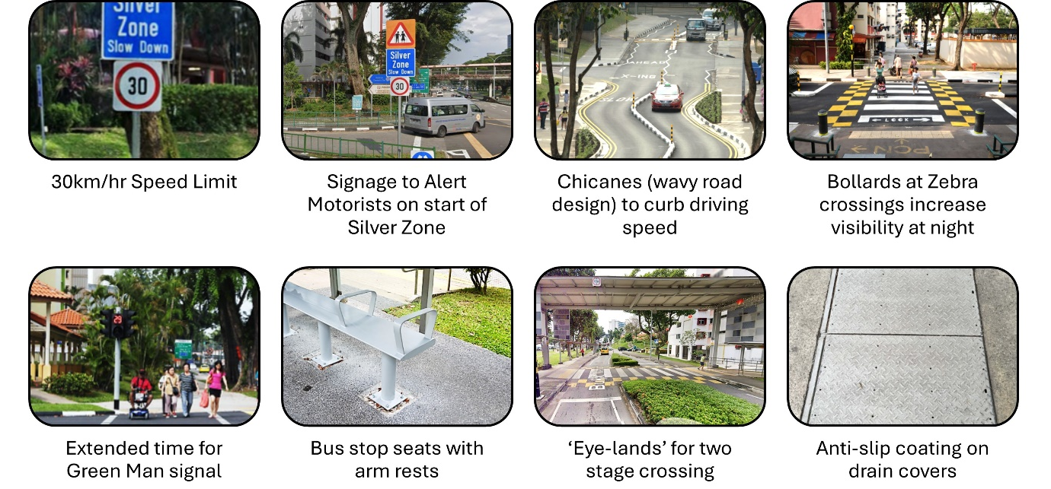
Resource 3 for Question 1

Questionnaire survey

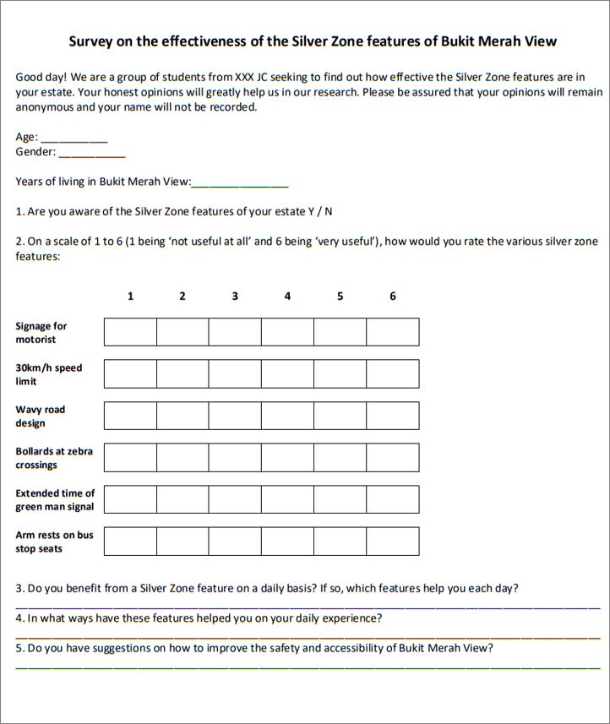

Resource 4 for Question 1

Raw data of the findings

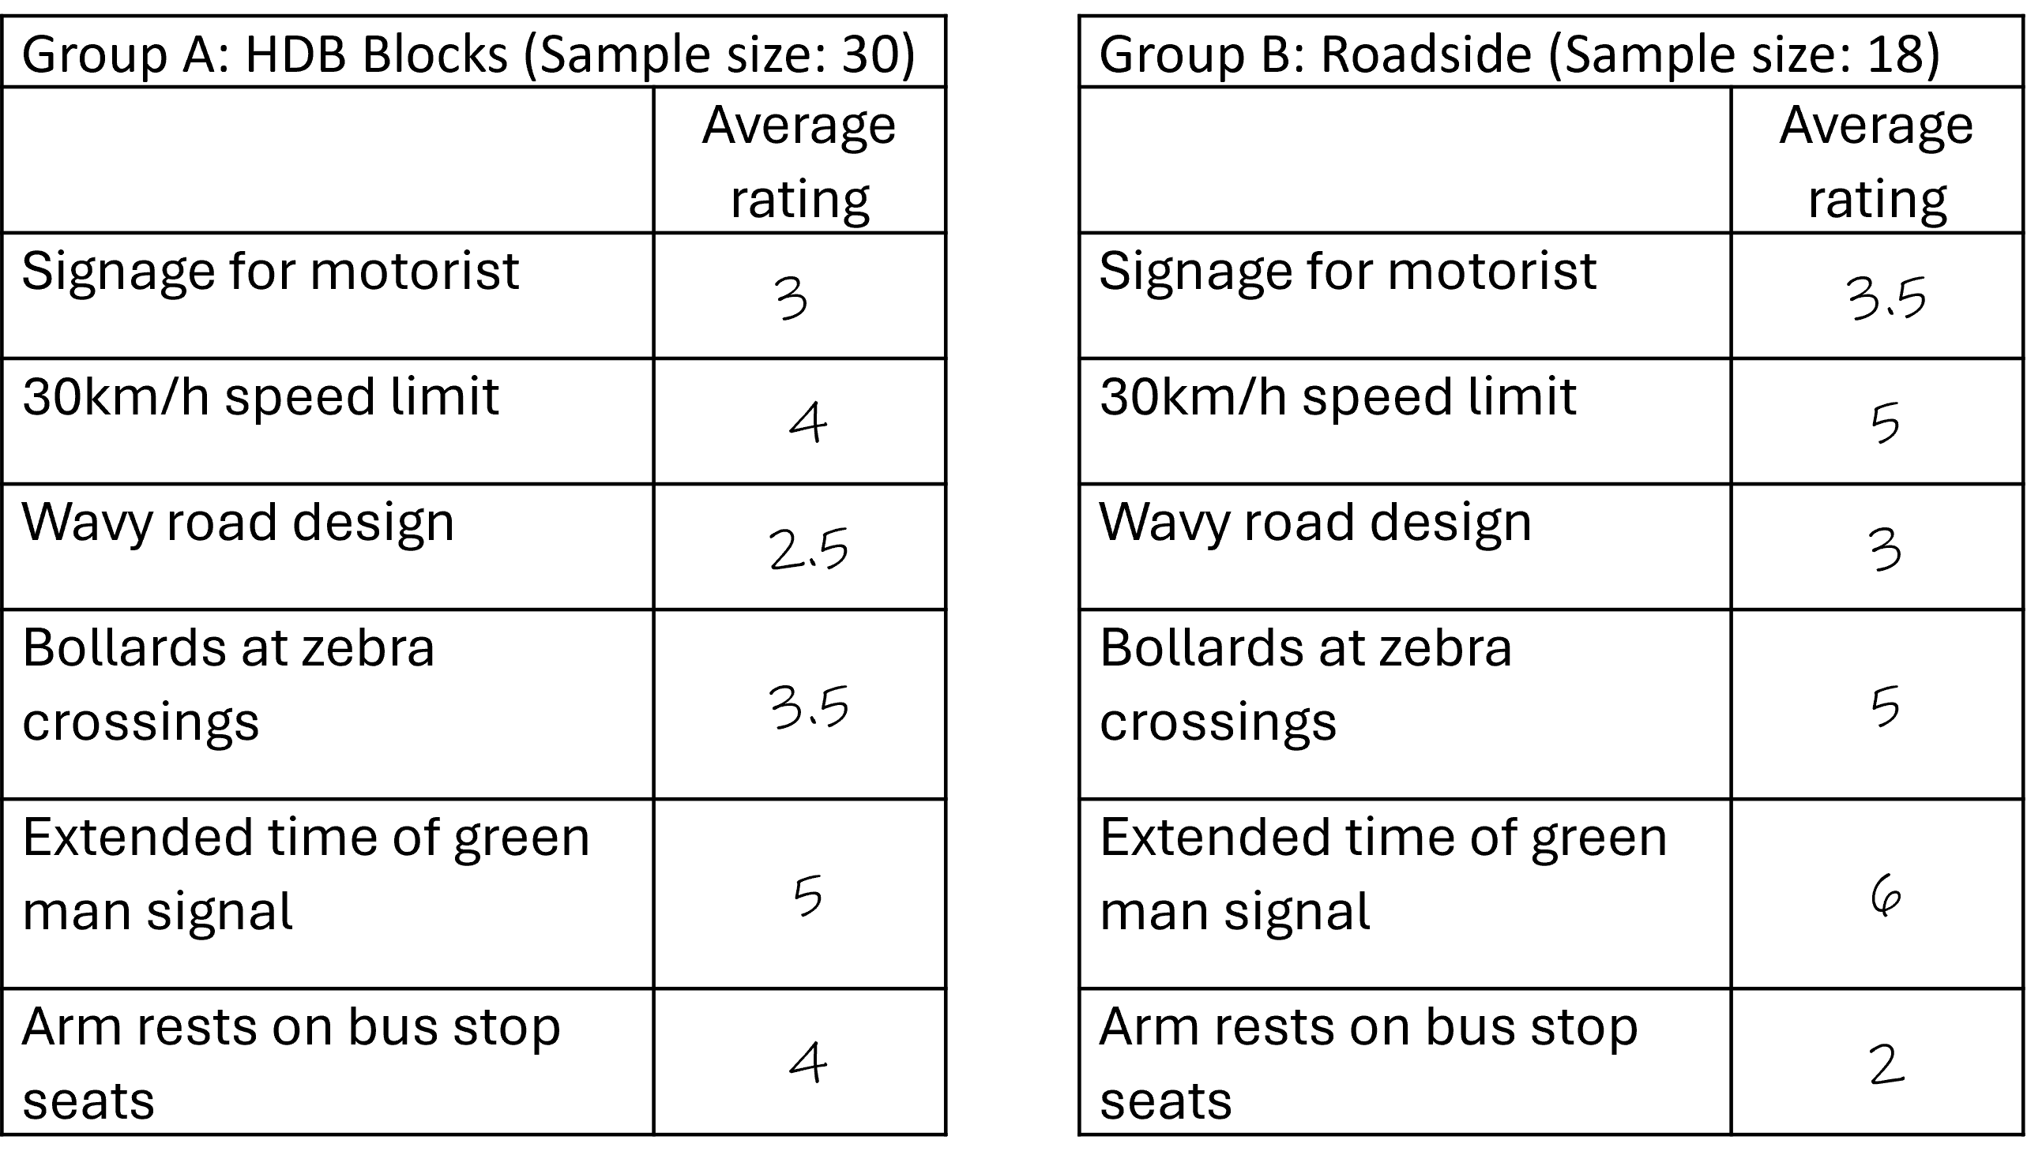

Resource 5 for Question 2

Global temperatures since 1880 as compared to the average global temperature for the mid-20th century years of 1951-1980
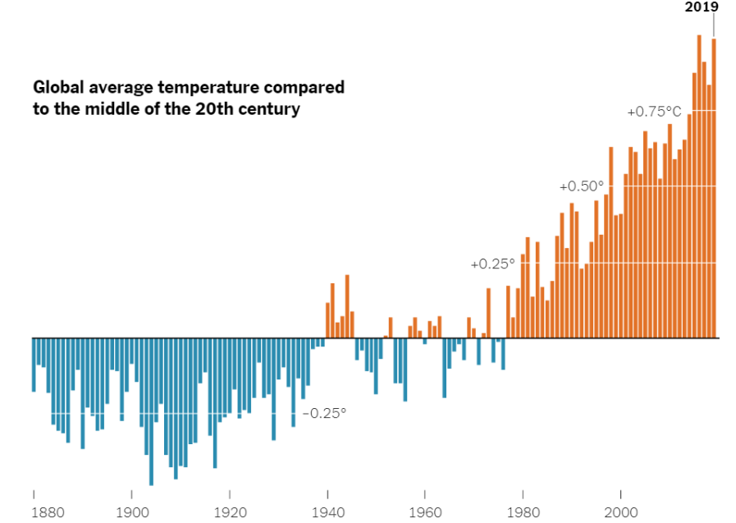

Resource 6 for Question 2

Simplified diagram of the greenhouse effect
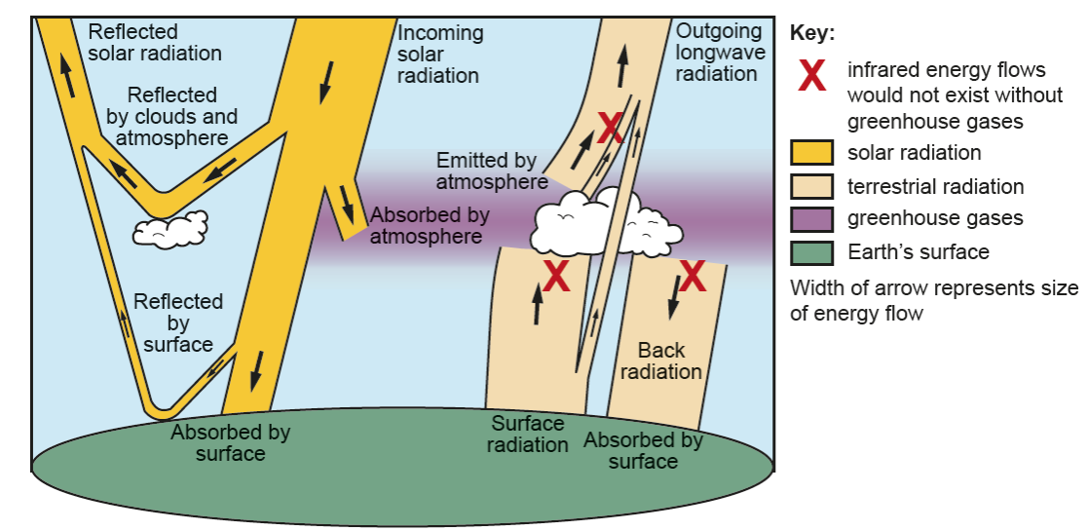

Resource 7 for Question 2

The ecological footprint, Human Development Index (HDI) and Happy Planet Index in selected countries for 2016
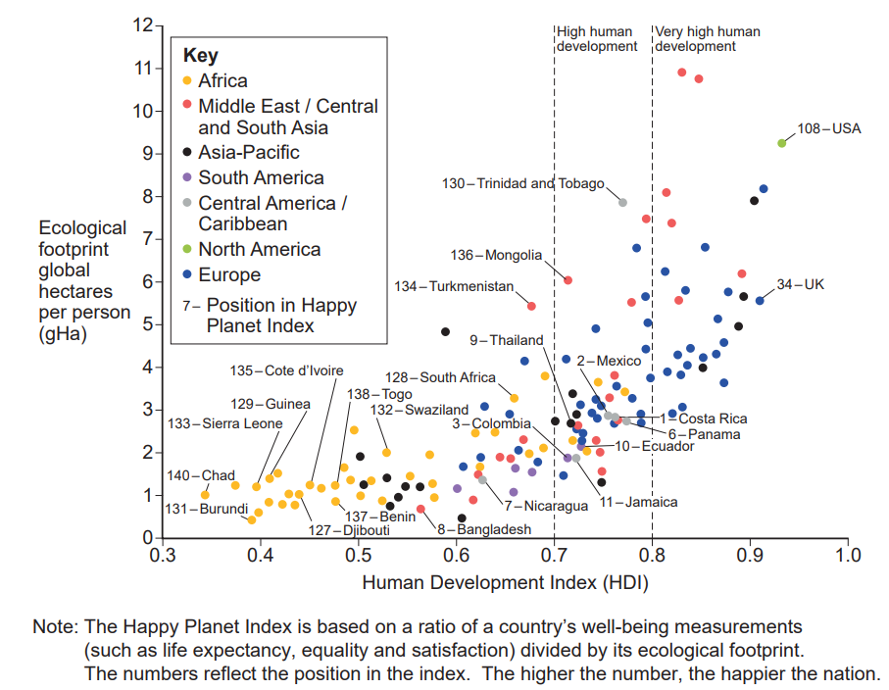

Resource 8 for Question 2

Ecological footprint, Population and GNI per person data
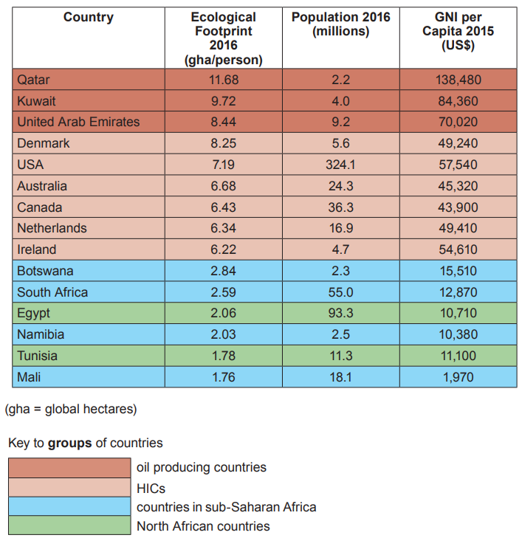

(High Income Countries)

BLANK PAGE

